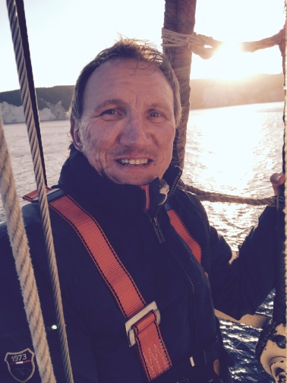

Name | Prof. Dr. Holger Kersten

Education
period | Details
1981 - 1986 | Study of Physics, Universities Jena and Greifswald (Germany), Diploma in 1986
1986 - 1989 | Research Student, University of Greifswald (Germany), PhD in 1990
1990 - 1996 | Research Assistant, University of Greifswald Germany)
1996 - 1997 | PostDoc, Technical University of Eindhoven (The Netherlands)
1997 - 2000 | Research Assistant (C1), University of Greifswald Germany), Habilitation in 2000

Professional experience
Period | Details
2001 - 2002 | Assistant Professor (C2), University Greifswald (Physics Department)
2003 - 2005 | Head of Department „Plasma Process Technology“, Leibniz-Institute for Plasma Research and technology (INP) Greifswald (Germany)
Since 2006 | Full Professor in Experimental Physics, University of Kiel (Germany)
Since 2008 | Guest Professor (plasma technology) at U Brno (Czech), U Koszalin (Poland), and U Kyushu (Japan)

Organizational experience
Period | Details
Since 2015 | Editor-in-Chief of Eur. Phys. J. D (EPJD)
Since 2014 | Director of Institute for Experimental and Applied Physics, U Kiel
2009 - 2013 | President of German Society for Plasma Technology
Since 2010 | Advisory Board of Plasma Surface Engineering (PSE), Garmisch-Partenkirchen,
Since 2006 | Member of Plasma Physics Board der European Physical Society (EPS)

