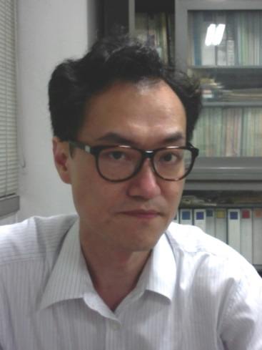

Name | Hiroshi Akatsuka

Education
period | Details
1981 – 1985 | Bachelor Course, Dept. Nuclear Engineering, Faculty of Engineering, Kyoto Univ.
1985 – 1987 | Master Course, Dept. Nuclear Engineering, Faculty of Engineering, Kyoto Univ.
1995 | PhD, Graduate School of Science and Engineering, Tokyo Institute of Technology

Professional experience
Period | Details
1987 – 1991 | Engineer, Dept. Laser and Millimeter Wave Communications Development,  Div. Space and Laser Communications Development, NEC Corporation
1991 – 1995 | Research Associate, Tokyo Institute of Technology
1995 – Present | Associate Professor, Tokyo Institute of Technology

Organizational experience
Period | Details
2010 – Present | Regional Editor, English Journal “Plasma and Fusion Research”,  The Japan Society of Plasma Science and Nuclear Fusion Research (JSPF)
2011 – 2011 | Vice Chair, Nuclear and Plasma Science Society (NPS-05), IEEE Japan Council
2011 – 2012 | Vice Chair, Technical Committee on Plasma Science and Technology (PST),  The Institute of Electrical Engineers of Japan (IEE Japan)
2012 – 2012 | Chair, NPS-05, IEEE Japan Council
2012 – 2015 | Chair, Technical Committee on PST, IEE Japan

